1.

import java.awt.Color;

public class JavaBank {

public static final Color LIGHT_BLUE = new Color(173, 216, 230);

}

import javax.swing.*;

public class JavaBankGUI {

public JavaBankGUI() {

JFrame frame = new JFrame("JavaBank");

JPanel panel = new JPanel();

// Set the background color to light blue

panel.setBackground(JavaBank.LIGHT_BLUE);

// Create a button and set its background color to light blue

JButton button = new JButton("Submit");

button.setBackground(JavaBank.LIGHT_BLUE);

// Add the button to the panel

panel.add(button);

// Add the panel to the frame

frame.add(panel);

// Set frame properties

frame.setSize(300, 200);

frame.setDefaultCloseOperation(JFrame.EXIT_ON_CLOSE);

frame.setVisible(true);

}

public static void main(String[] args) {

new JavaBankGUI();

}

}

2. package bikeproject;

public interface Bikeparts

{

public final String ***Make***="Oracle Bikes";

public String getHandleBars();

public void setHandleBars(String newValue);

public String getTyres();

public void setTyres(String newValue);

public String getSeatType();

public void setSeatType(String newValue);

}

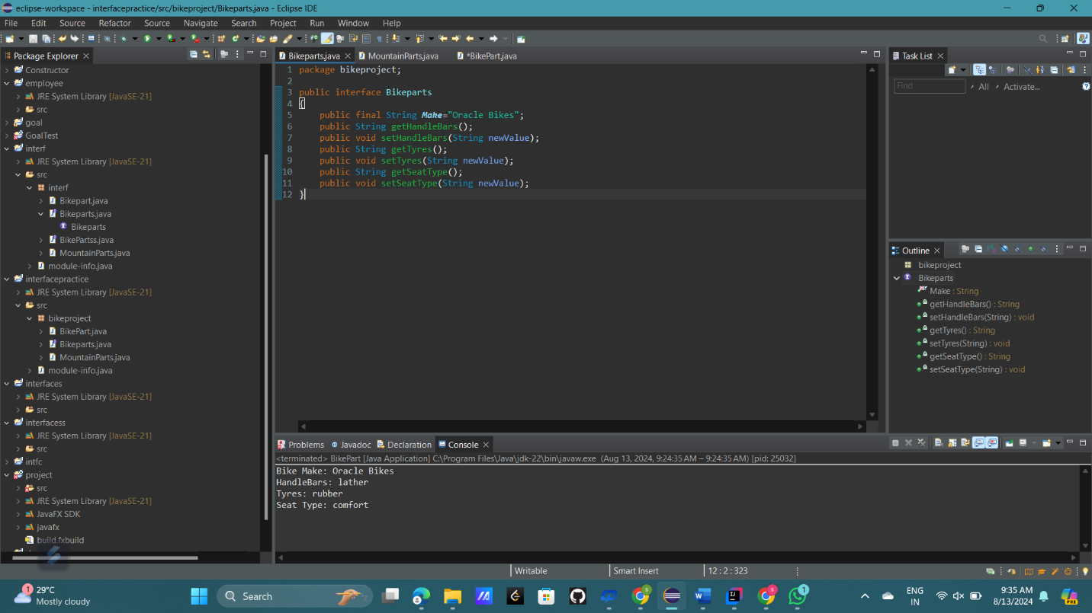

3. package bikeproject;

public interface MountainPart

{

public final String ***TERRAIN*** = "off_road";

public String getSuspension();

public void setSuspension(String newValue);

public String getType();

public void setType(String newValue);

}

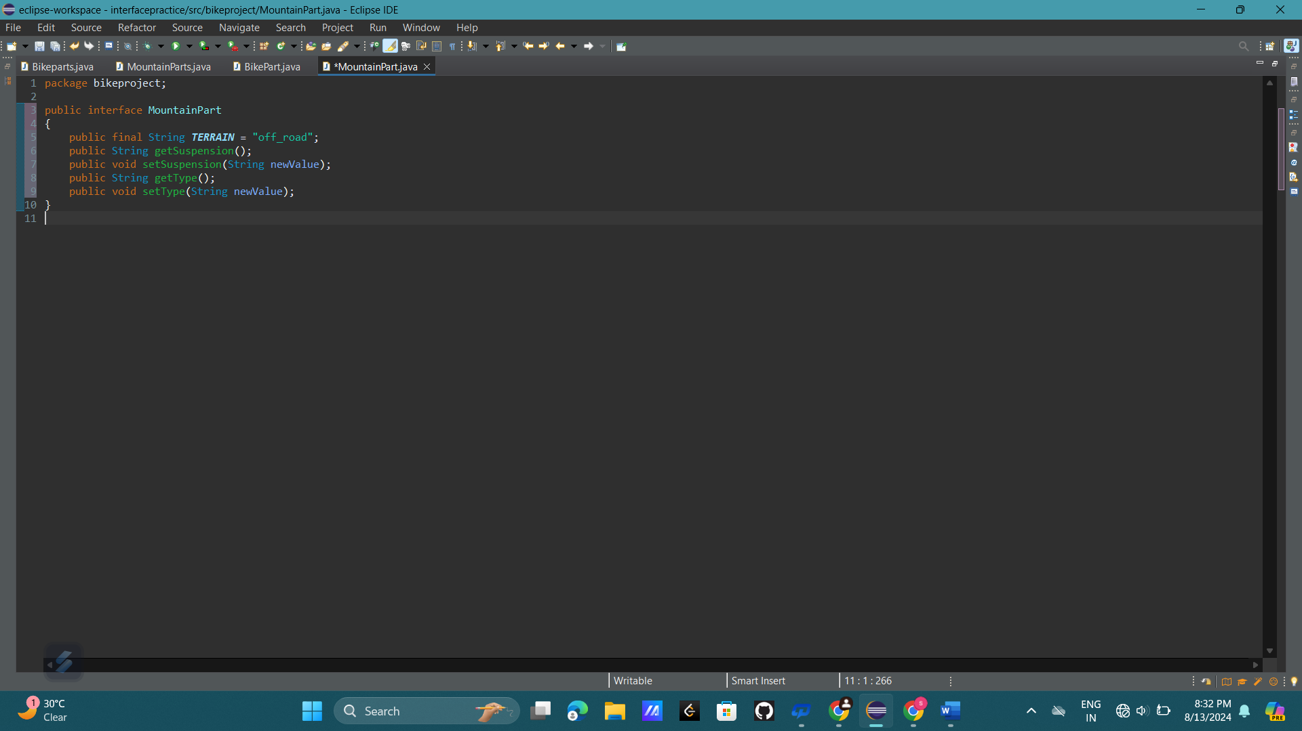

4. package bikeproject;

public interface RoadParts

{

public final String ***TERRAIN*** = "track_racing";

public String getTyreWidth();

public void setTyreWidth(String newValue);

public String getPostHeight();

public void setPostHeight(String newValue);

}

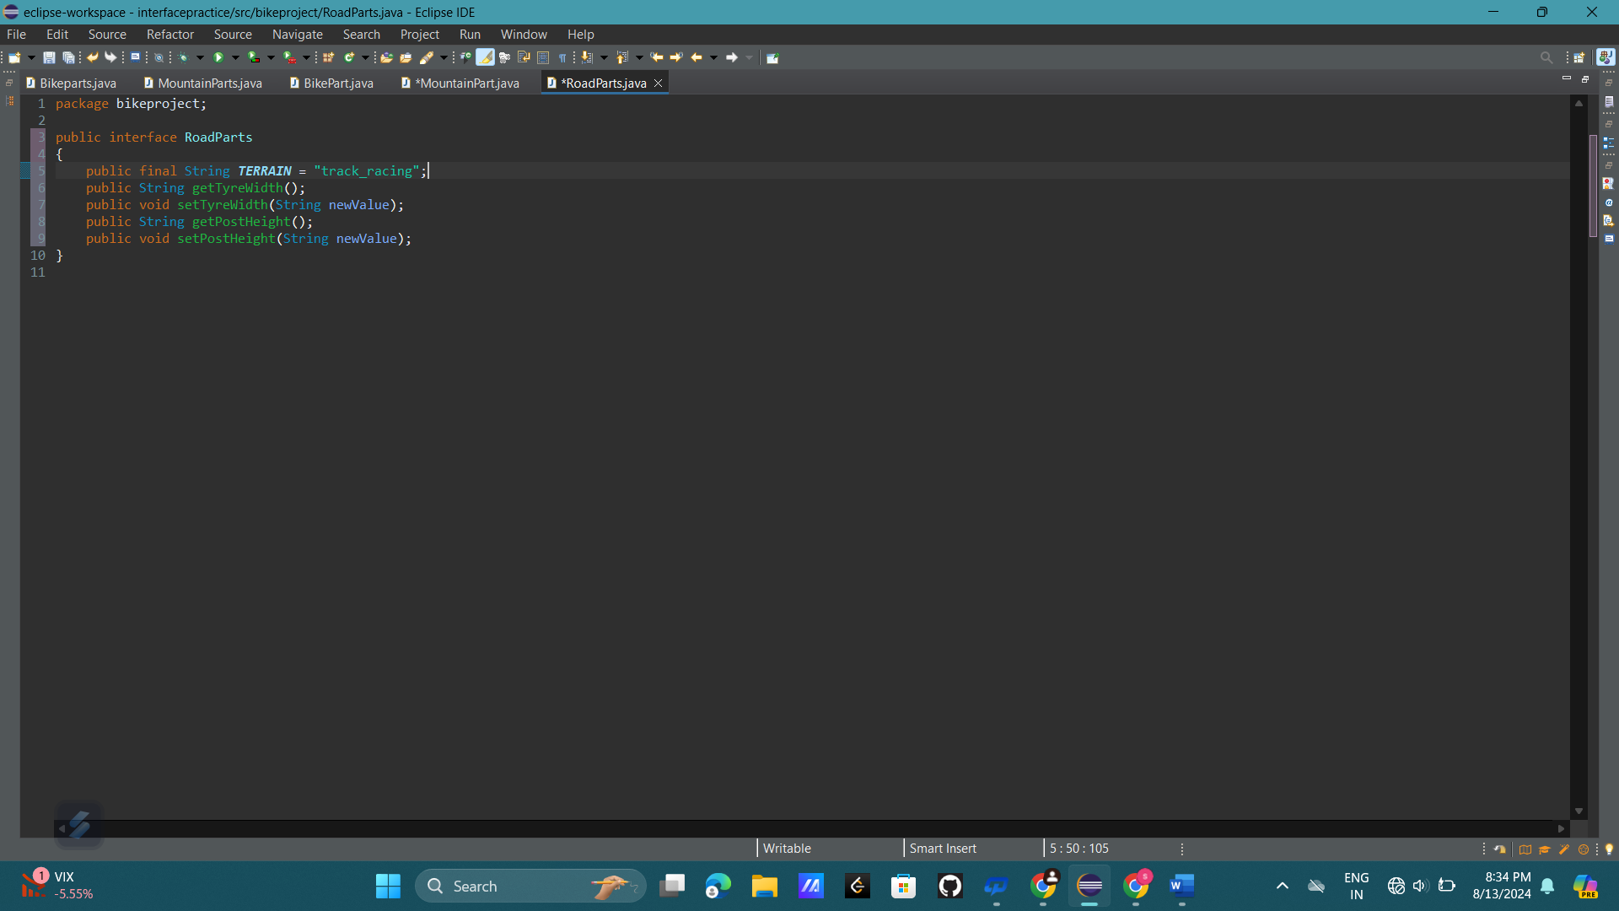

5. package bikeproject;

public class Bike implements Bikeparts

{

private String handleBars;

private String tyres;

private String seatType;

public Bike(String handleBars, String tyres, String seatType) {

this.handleBars = handleBars;

this.tyres = tyres;

this.seatType = seatType;

}

public String getHandleBars() {

return handleBars;

}

public void setHandleBars(String newValue) {

handleBars = newValue;

}

public String getTyres() {

return tyres;

}

public void setTyres(String newValue) {

tyres = newValue;

}

public String getSeatType() {

return seatType;

}

public void setSeatType(String newValue) {

seatType = newValue;

}

}

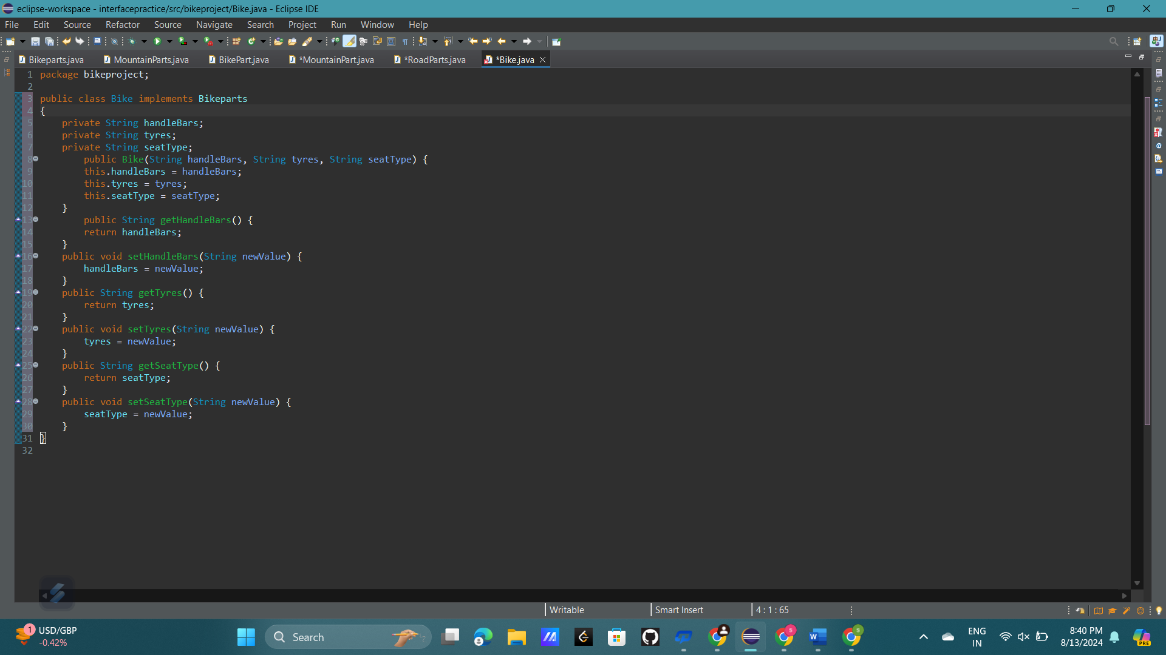

6. package bikeproject;

public class MountainBike extends Bike implements Mountainparts {

private String suspension;

private String type;

public MountainBike(String handleBars, String tyres, String seatType, String suspension, String type) {

super(handleBars, tyres, seatType);

this.suspension = suspension;

this.type = type;

}

public String getSuspension() {

return suspension;

}

public void setSuspension(String newValue) {

suspension = newValue;

}

public String getType() {

return type;

}

public void setType(String newValue) {

type = newValue;

}

}

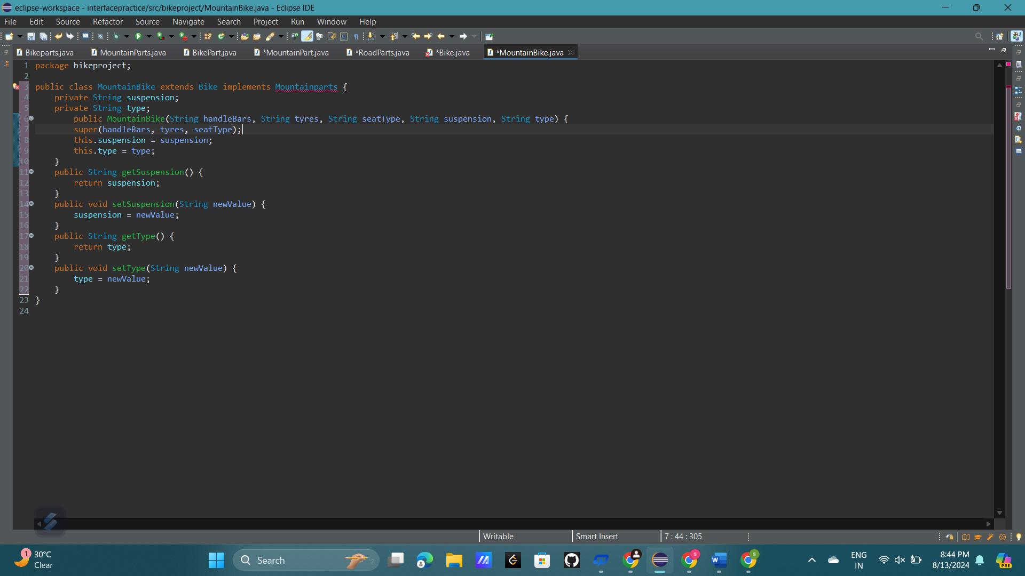

7. package bikeproject;

public class Bike implements Bikeparts

{

private String handleBars;

private String tyres;

private String seatType;

public Bike(String handleBars, String tyres, String seatType) {

this.handleBars = handleBars;

this.tyres = tyres;

this.seatType = seatType;

}

public String getHandleBars() {

return handleBars;

}

public void setHandleBars(String newValue) {

handleBars = newValue;

}

public String getTyres() {

return tyres;

}

public void setTyres(String newValue) {

tyres = newValue;

}

public String getSeatType() {

return seatType;

}

public void setSeatType(String newValue) {

seatType = newValue;

}

}

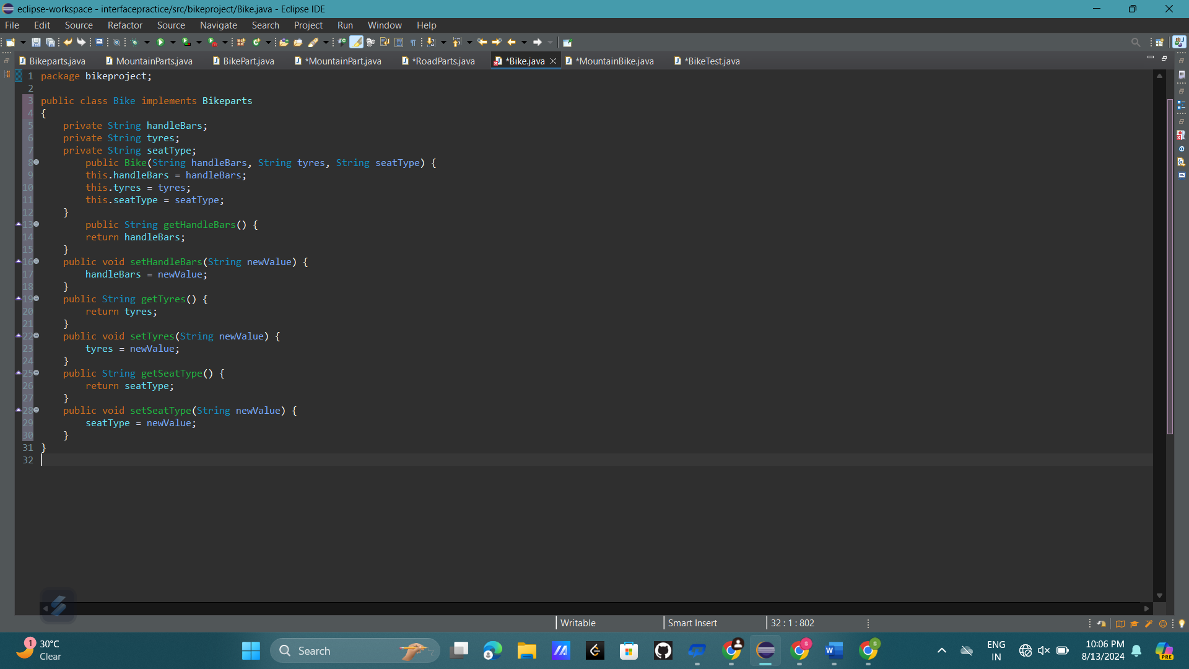

8,9. package bikeproject;

public class BikeTest {

public static void main(String[] args) {

Bike bike = new Bike("Standard", "All-Terrain", "Comfort");

MountainBike mountainBike = new MountainBike("Mountain", "Knobby", "Racing", "Full", "Downhill");

RoadBikes roadBike = new RoadBikes("Road", "Smooth", "Sport", "Narrow", "22");

roadBike.setPostHeight("20");

System.***out***.println("Bike Details:");

System.***out***.println("Handle Bars: " + bike.getHandleBars());

System.***out***.println("Tyres: " + bike.getTyres());

System.***out***.println("Seat Type: " + bike.getSeatType());

System.***out***.println("\nMountain Bike Details:");

System.***out***.println("Handle Bars: " + mountainBike.getHandleBars());

System.***out***.println("Tyres: " + mountainBike.getTyres());

System.***out***.println("Seat Type: " + mountainBike.getSeatType());

System.***out***.println("Suspension: " + mountainBike.getSuspension());

System.***out***.println("Type: " + mountainBike.getType());

System.***out***.println("\nRoad Bike Details:");

System.***out***.println("Handle Bars: " + roadBike.getHandleBars());

System.***out***.println("Tyres: " + roadBike.getTyres());

System.***out***.println("Seat Type: " + roadBike.getSeatType());

System.***out***.println("Tyre Width: " + roadBike.getTyreWidth());

System.***out***.println("Post Height: " + roadBike.getPostHeight());

}

}

10,11.

